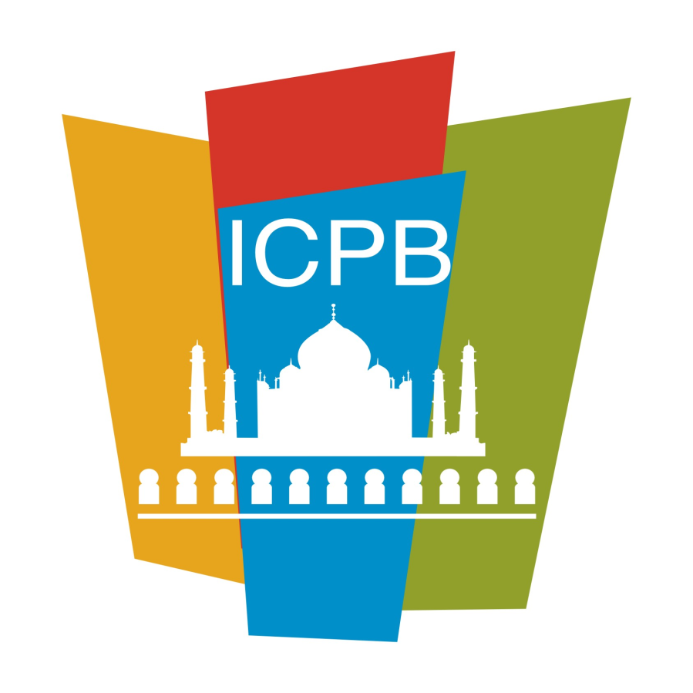

MEMBERSHIP APPLICATION FORM
FOR
Airlines

India Convention Promotion Bureau (ICPB)
(Sponsored by Ministry of Tourism, Government of India)
Room No. 233A, Ashok Hotel, Niti Marg, Chanakyapuri, New Delhi – 110021 INDIA
Tel: 91-11-26110101 Extn. 3186
E. connect@icpb.in , W. www.icpb.in

Date: _______________________

To,

The Executive Director,
India Convention Promotion Bureau (ICPB),
(Sponsored by Ministry of Tourism, Government of India)
Room No. 233A, Ashok Hotel,
Niti Marg, Chanakyapuri,
New Delhi – 110021, INDIA

Subject: New Membership
Sir,
I/We hereby, apply for the Membership of the Indian Convention Promotion Bureau (ICPB), New Delhi as an Airline under Active category.
I/We agree to abide by the Memorandum of Association and rules and regulations of ICPB, New Delhi for the time being in force or any other rules or regulations or code of conduct prescribed both by the Governing Board / Bureau /Government from time to time.

I/We undertake to pay the annual subscription fee and hereby declare that the particulars given in the application are true and correct to the best of my/our knowledge and belief.

Yours faithfully,

(To be signed by the Authorized Representative)
Company Stamp

(Note: The application to the Bureau does not guarantee your selection as member).

Brief introduction about ICPB
As the MICE segment is flourishing in developed countries, the potential in India has also been discovered and companies are actively engaged in this segment.
To promote India more effectively as a convention destination, India Convention Promotion Bureau (ICPB) was set up in the year 1988 jointly by the Ministry of Tourism, Government of India and the Industry and Trade.
The Bureau has been undertaking various activities to boost India’s potential as a MICE destination. Based on feedback from members, ICPB is taking new initiatives for the further growth of the MICE business in India.
AIRLINES is a professional services company with local knowledge, expertise and resources, working in the design and implementation of events, activities, tours, transportation and program logistics.
Applicable Admission fee and annual subscription charges
Category/Segment | Membership Fee | Application Fee (One Time) | GST | First Time | Annual Subscription Charges
Active (AIRLINES ) | 35,000/- | 10,000/- | 18% | 53,100/- | 41,300/-

(*) GST – as per Govt. rules, currently @18%

Benefits
- Increased exposure and opportunities for business networking.
- Upgrading of professional skills through training programs.
- Free listing on ICPB's website and member's directory.
- Participation at ICPB events for showcasing products / services to the clients across the world and also networking with potential buyers at nominal cost.
- Sharing of business leads received in ICPB through queries on mail, participation at international tradeshows and in-house data research.
- Part of decision making by contributing your inputs for submission of proposals to the Ministry of Tourism, Government of India.
- Participation in international MICE trade shows like IMEX Las Vegas, IMEX Frankfurt, AIME-Melbourne etc. under Indiatourism stand at nominal cost. (Under Incredible India banner of MoT)
- Participation at International Road Shows under Incredible India banner nominal cost.
- Use of ICPB logo. (As per logo guidelines of ICPB)
- Assist in MEA clearance for international conferences and E-Conference Visa.
- To provide support letters to strengthen bids for winning international conferences. This is an important requirement of most international associations.
- Membership Committee will welcome & support new members with mentorship.
- ICPB periodically organises training / skill development programs for members.
- Creating a business platform for members.
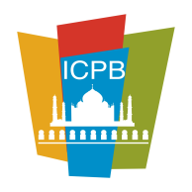
India Convention Promotion Bureau (ICPB)
(Sponsored by Ministry of Tourism, Government of India)
Room No. 233A, Ashok Hotel, Niti Marg, Chanakyapuri, New Delhi – 110021 INDIA
Tel: 91-11-26110101 Extn. 3186

A. DETAILS TO BE FILLED-IN BY APPLICANT COMPANY
- Name of the Organiser
- Registered Address
- Telephone/e-mail /website

4. Date of Establishment
5. Branch Offices, if any
6. Name and address of Office in Delhi, if any (Please specify whether Branch /Liaison / Representative office)
7.Company | Public / Private / Partnership / Society / Proprietorship / Others (pls. specify)
8. Functions and objectives of the company. (Please attach company profile along with a copy of Memorandum & Articles of Association in case of Registered Company and Association / Partnership Deed (in case of Partnership)
9. Name of members(s) of the Board of Directors /Partners/ Proprietors (List to be attached)

India Convention Promotion Bureau (ICPB)
(Sponsored by Ministry of Tourism, Government of India)
Room No. 233A, Ashok Hotel, Niti Marg, Chanakyapuri, New Delhi – 110021 INDIA
Tel: 91-11-26110101 Extn. 3186

10. Business performance for the past three years (certificate from a qualified Chartered Accountant to be attached)
11 Provide details of Service Tax No. / PAN No./ GST etc. Attested copy for the document to be attached.
12. Please attach a sheet with the information of conferences / conventions / exhibitions and events etc. organized / handled in past two year with Pax etc. (Please attached separate sheet)
13.(i) Are you approved by the Department of Tourism, Govt. Of India as a Travel Agent OR Tour Operator ? | Yes / No
(ii) If no, have you applied to Dept. for approval? | YES/ NO  - If yes, pls. provide photocopy of the relevant correspondence.
14. Provide details of qualified / Trained Conference Professionals in your organisation.
15. Provide the names of the Industry / Trade Association, your company is currently member.
16. Name and address of person & Office who will represent your company at ICPB
Name
Designation
Tel. No.
Fax No.
Mobile No.
E-mail.

17. Any other relevant information or details that will facilitate evaluation of your application. (pls. mention and attach separate sheet, if required)

India Convention Promotion Bureau (ICPB)
(Sponsored by Ministry of Tourism, Government of India)
Room No. 233A, Ashok Hotel, Niti Marg, Chanakyapuri, New Delhi – 110021 INDIA
Tel: 91-11- 26110101 Extn. 3186

B. Supporting Documents required
- As stated above in the application form (Sl. No. 8 to 12).
- Letter of approval by the Ministry of Tourism, Govt. Of India, if any. (Sl. No. 13 (1) and (II)
- Cheque / Demand Draft no./NEFT/Online …………………………. Dated…………………for Rs……………………. Favoring India Convention Promotion Bureau towards admission fee and / or Annual Subscription charges as per our membership plus applicable services tax.

- I/We also undertake that we shall not use ICPB (Indian Convention Promotion Bureau) logo or name to defame it or its event/s.
- I/We confirm that our company is not black listed by any govt. or semi organization, association etc.
- I/We undertake that the information provided in this application form are correct and true to the best of our knowledge and belief. We are fully responsible for any mis-declaration, if any, provided to Bureau, at any stage.
- I/We agree to abide by the Memorandum of Association and Rules & Regulations of the INDIA CONVENTION PROMOTION BUREAU, (ICPB) & pay the annual charges.

Place & date: ___________________________________

Signature ___________________________________

Name of Authorized Signatory ___________________________________
Designation ___________________________________
Company Name ___________________________________
Address ___________________________________
_______________________________________

India Convention Promotion Bureau (ICPB)
(Sponsored by Ministry of Tourism, Government of India)
Room No. 233A, Ashok Hotel, Niti Marg, Chanakyapuri, New Delhi – 110021 INDIA
Tel: 91-11- 26110101 Extn. 3186

Membership eligibility for AIRLINES

- Organization should be registered under Companies Act and have Incorporation Certificate.
- Working capital should be minimum Rs. 3.00 lacs & authorized capital Rs. 10.00 lacs
- Organization should have submitted ITR for the last 3 financial years.
- Balance sheet/CA Certificate for last 3 financial years.
- Organization should have a PAN, TAN & GST registration certificate.
- Three qualified staff, qualified with diploma/degree in Tourism/ Travel Management from an approved University include deemed University IITTM, Institutions approved by AICTE or basic certificate holder of IITFC apart from promoters of the company.
- Organization should have been recommended by at least one ICPB member.
- MoT approval under Tour Operator/Travel Agent category/Domestic Tour Operator.

Must have experience in:
- Company should be registered under companies act.
- Working capital should be at least Rs. 3.00 lacs & authorized capital should be at least Rs. 10.00 lacs
- Organization should be recommended by at least one ICPB member.
- Three years of existence of organization.

INDIA CONVENTION PROMOTION BUREAU
Code of Conduct and Best Practices
- We as ICPB members will strive continuously to improve professional standards within the MICE industry in tune with the international norms and quality standards.
- Act professionally in all circumstances and in particular in relation to clients, suppliers, MICE professionals, fellow members and the public.
- Represent their capabilities and services to potential clients and confirmed clients in an honest and professional manner, negotiate and agree on terms with a client, on the basis of the resources, that can reasonably be expected to be supplied.
- Inform client of the conditions of engagement and scale of charges and agree that these conditions shall be the basis of the appointment.
- To clearly mention charges and fees, as applicable and not attempt to get the contract by false representation. This will be treated as un-ethical trade practice.
- Conduct business with integrity, in a manner which is not derogatory to the profession, nor bring ICPB and the country into disrepute, compete fairly with other members of the industry.
- Governing Board membership should not use ICPB visiting card for commercial use.
- Code of ethics applicable for hiring of employees within the trade.
- Not to indulge in monopolistic and un-ethical trade practices.

Confidentiality – ICPB members will treat every client transaction confidentially and not disclose any information without permission of the client, unless required by law.

Relationship amongst members:
- An ICPB member shall use the ICPB logos as an emblem of the highest standards of professional conduct and service.
- Observer member is not entitled to use ICPB logo.
- No member shall solicit a proposal or seek terms, conditions, format or ideas from another with the intent of taking unfair advantage of the solicitation or with deliberate intent of using that information to manage his/her own program without the services of that company.
- No member shall take confidential information or creative ideas of his/her competition and/or current or former employer(s) and present them to customers as his/her own exclusive creation.
- No member shall knowingly make false or misleading statements:
- About competitors.
- To secure otherwise confidential information
- About the member’s expertise or ability successfully and professionally to meet a potential client’s needs.
- About rates, costs, accommodations, transportation, capacities or any other factors regarding a proposed program.
Employment:
- ICPB member before recruiting an employee, issue the Letter of Intent and at the same time of the joining of the employee seek the “Clearance Certificate” when due.
- No member shall solicit/ demand/ take from a new employee any confidential information or creative ideas of his/her previous employer.
- Any misrepresentation of fact by employees should be reported by ICPB members to ICPB Secretariat. So that, all the other members are alerted and cautioned.
Compliance and Conclusion
We have read the Code of Conduct, have acceptance and recognition thereof, would follow Code of Conduct in its letter and spirit, and conduct business accordingly. Breach of any of the above articles, may result in a disciplinary action including expulsion from ICPB, as well as reporting to the concerned authorities.
Members shall co-operate in any investigation undertaken by ICPB into an alleged breach of the Code of Conduct and shall comply with the procedures of investigation and enforcement.
Name __________________________________________________________________________________
Designation_____________________________________________________________________________
Organization____________________________________________________________________________
Date____________________________________________________________________________
Place____________________________________________________________________________
Signature

******

